Java Overview of Build Automation Tools
What is Build Automation?
Build automation is the process of automatically converting source code into a runnable application.
It includes:
- Downloading required libraries (dependencies)
- Compiling source code
- Running tests
- Packaging the application (JAR/WAR)
- Deploying the application
Instead of doing these steps manually, build tools do everything automatically.
Why Build Automation is Needed in DevOps?
In DevOps:
- Code changes happen frequently
- Multiple developers work together
- Continuous Integration (CI) is required
So we need tools that:
- Build code automatically
- Ensure consistency
- Reduce human errors
- Work smoothly with CI/CD pipelines
Maven and Gradle are the most popular build automation tools used in DevOps.
Apache Maven – Introduction
What is Maven?
Maven is a Java-based build automation and dependency management tool.
It follows:
- Convention over Configuration
- XML-based configuration
Main configuration file:
pom.xml (POM = Project Object Model)
Key Features of Maven
- Simple project structure
- Automatic dependency download
- Predefined build lifecycle
- Easy integration with Jenkins, Git, CI tools
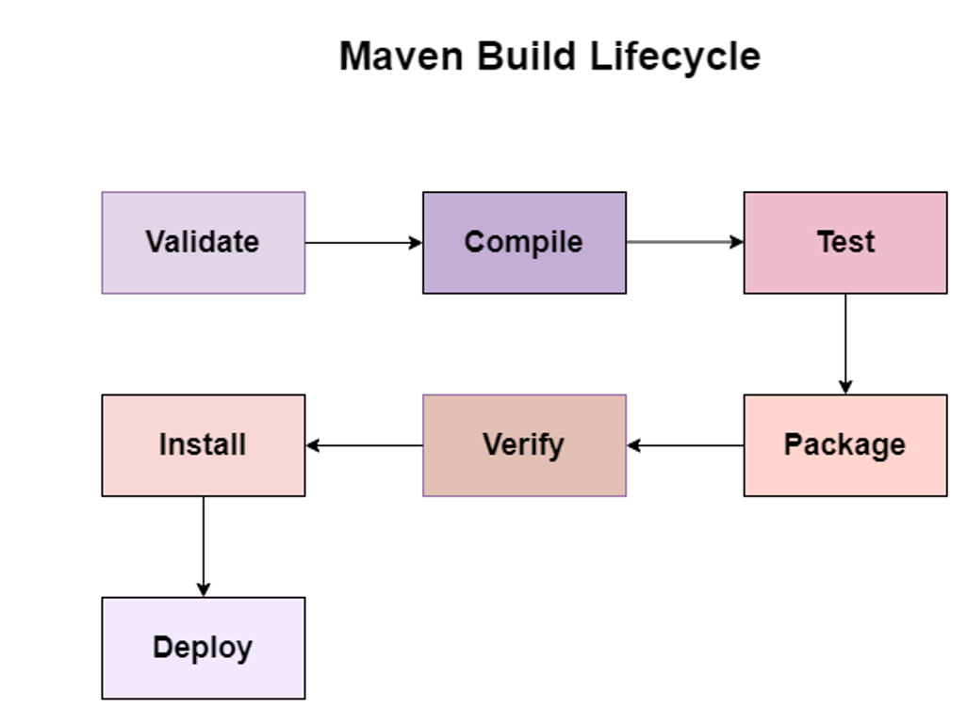
What is Maven Build Lifecycle?
The Maven Build Lifecycle is a sequence of well-defined phases that Maven follows to build and manage a project.
These phases decide what action Maven performs at each step of the build process.
Maven lifecycle is fixed and predefined the order of phases cannot be changed

What happens in validate?
- Checks whether:
  - Project structure is correct
  - pom.xml is valid
  - Required information (groupId, artifactId, version) exists
What happens in compile?
- Compiles Java source code
- Converts .java files into .class files
- Stores compiled code in: target/classes
What happens in test?
- Runs unit test cases
- Uses testing frameworks like JUnit
- Test results are shown in console
- Compiles test code, Executes test cases and Does not package the application.
What happens in package?
- Takes compiled code
- Packages it into a distributable format:
  - JAR (Java Archive)
    - WAR (Web Application Archive)
What happens in verify?
- Performs additional checks
- Verifies:
  - Code quality
  - Integration test results
  - Build correctness
Ensures the package is valid and reliable
What happens in install?
- Installs the generated package into local Maven repository
- Local repository location: ~/.m2/repository
What happens in deploy?
- Uploads the final package to a remote repository
  - Nexus
  - Artifactory
Used in CI/CD pipelines

Gradle
Gradle is a build automation and dependency management tool used mainly for:
- Java projects
- Android applications
- Modern DevOps pipelines
Just like Maven:
- Gradle builds your project
- Gradle manages dependencies automatically
Why Gradle is Needed?
Maven is good, but:
- It is slower
- Uses long XML files
- Less flexible
Gradle was created to:
- Be faster
- Be more flexible
- Use simpler scripts
How Gradle Works (Very Simple Flow)
- You declare dependencies in a file
- You run a build command
- Gradle:
  - Downloads dependencies
  - Compiles code
  - Runs tests
  - Creates output (JAR/APK)
No separate download command needed
Gradle Configuration File: gradle uses build.gradle This file is written in Groovy (or Kotlin).
Gradle has a task-based lifecycle with 3 main stages.
Initialization → Configuration → Execution
Initialization Phase
What happens here?
- Gradle identifies:
  - Which project(s) to build
  - Reads settings.gradle
- Creates a Project object for each project
- No tasks are run here
- Just prepares the build
Example:
gradle build
Gradle first checks:
- Is it a single project or multi-project?
- Which modules are included?

Configuration Phase
What happens here?
- Gradle reads:
  - build.gradle
- All tasks are:
  - Defined
  - Configured
- Dependency graph is created
Important: Tasks are configured, not executed
Example:
task hello {
doLast {
println "Hello DevOps"
}
}
At this stage:
- Gradle knows what tasks exist
- Gradle knows task dependencies

Execution Phase
What happens here?
- Gradle executes only the required tasks
- Tasks are executed in correct order
This makes Gradle faster than Maven
Example:
gradle hello
Only hello task runs, not the entire build.

Installation of Maven and Gradle (Step-by-Step)
Step 1: Open Command Prompt
In Windows:
- Press Windows + R
- Type: cmd , Press Ok
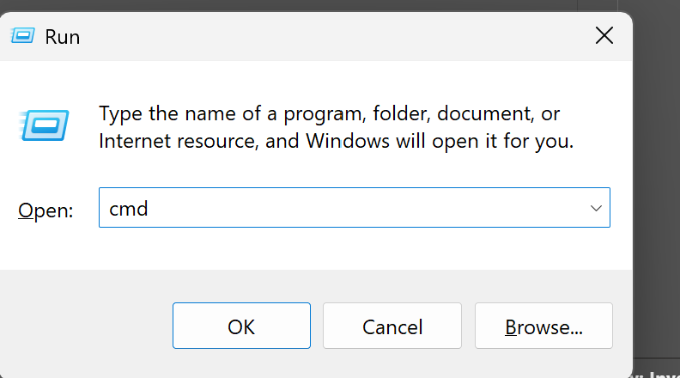
Step 2: Check Java Version
java -version if you see the version continue with step 4
If you see: 'java' is not recognized as an internal or external command, JDK is NOT installed

Step 2: Download JDK
- Download JDK 8 or above
- Download the Windows installer (.exe)
Accept license & default settings
Step 3: Install JDK
- Double-click the downloaded .exe
- Click Next → Next → Install
- Installation path example:
- Click Finish
C:\Program Files\Java\jdk-25

Step 4: Set JAVA_HOME (Very Important)
Why?
- Maven and Gradle look for Java using JAVA_HOME

How to Set JAVA_HOME (Windows)
- Open System Properties
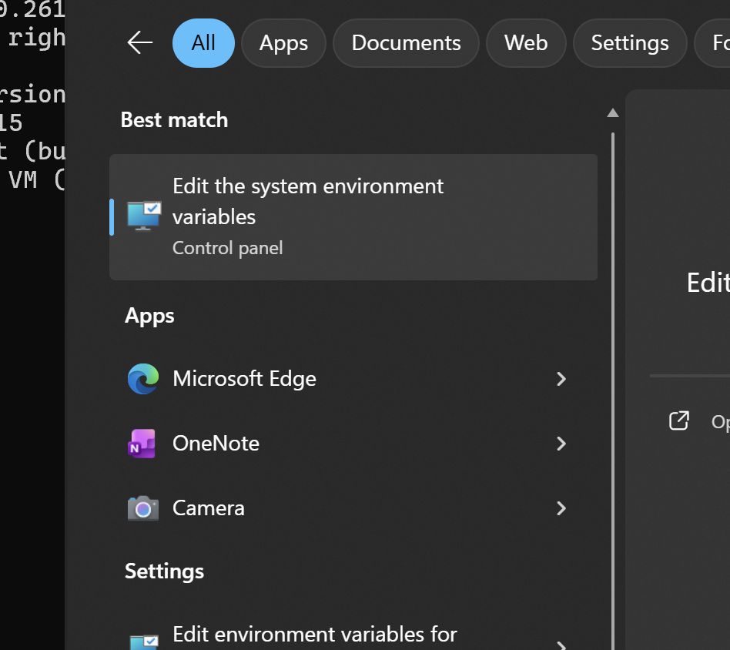
  - Right-click This PC → Properties
  - Click Advanced system settings
- Click Environment Variables
- Under System Variables, click New
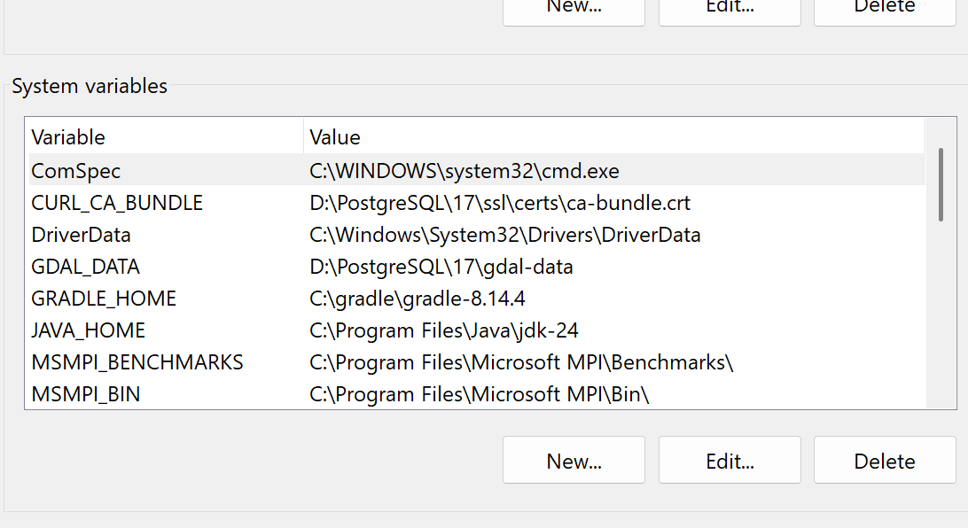
Variable Name: JAVA_HOME
Variable Value: C:\Program Files\Java\jdk-24 (this is the location of the jdk-24)
Click OK
Step 5: Update PATH Variable
- In System Variables
- Select Path → Edit
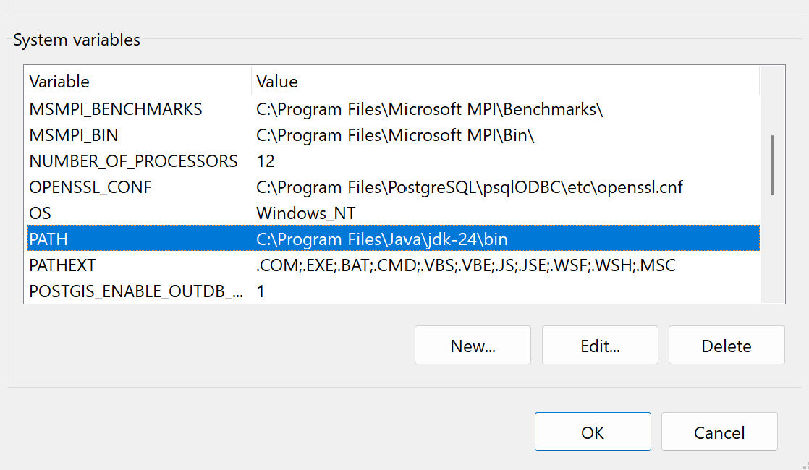
Value = %JAVA_HOME%\bin or C:\Program Files\Java\jdk-24\bin
- Click OK → OK

Step 6: Verify JDK Installation
Close and reopen Command Prompt, then run: java -version
Expected Output:
java version "25.0.x"
JDK installed successfully
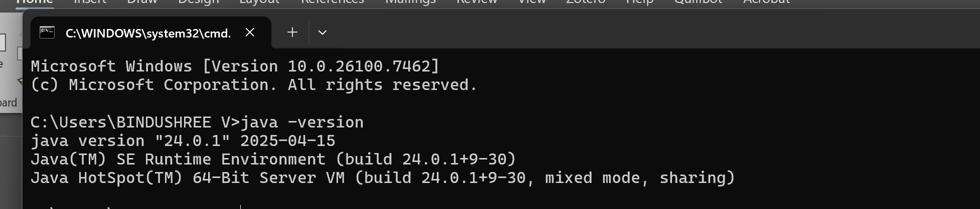
Installing Apache Maven
Step 1: Download Maven
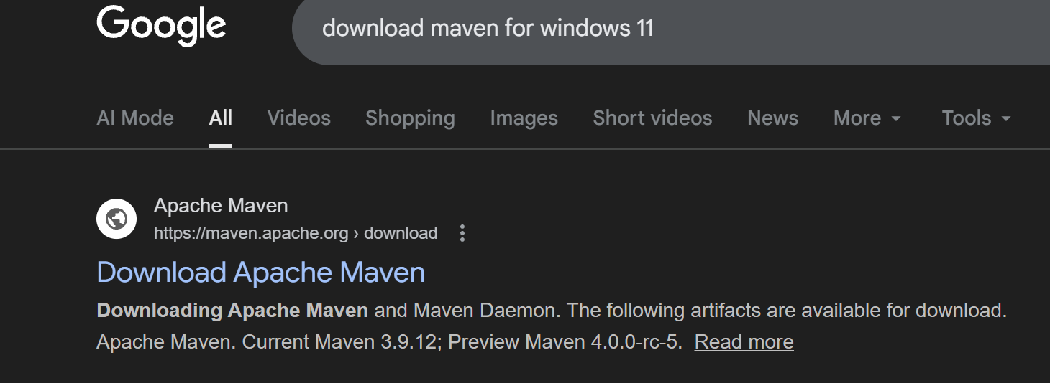
- Download Apache Maven (binary zip)
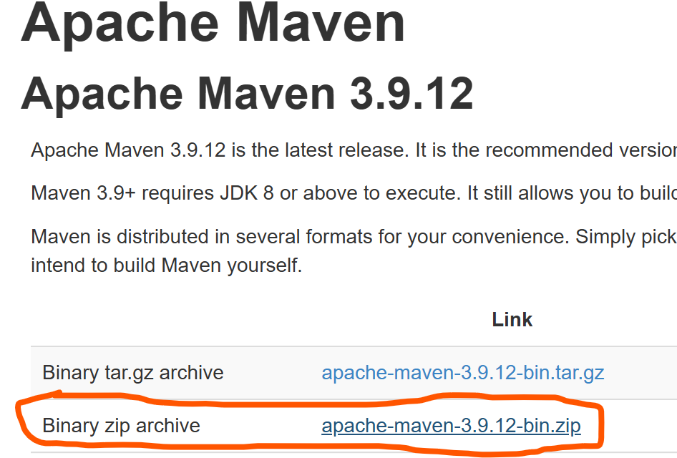
- Extract the zip file

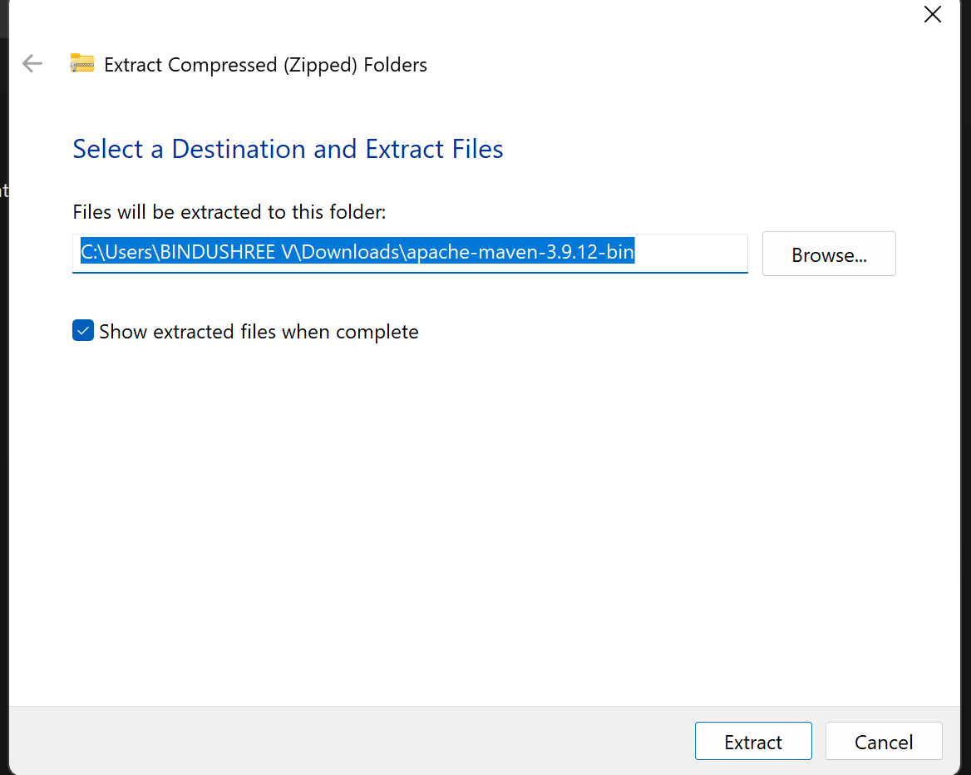

Example location:
C:\apache-maven-3.9.12
Step 2: Set MAVEN_HOME
- Open Environment Variables
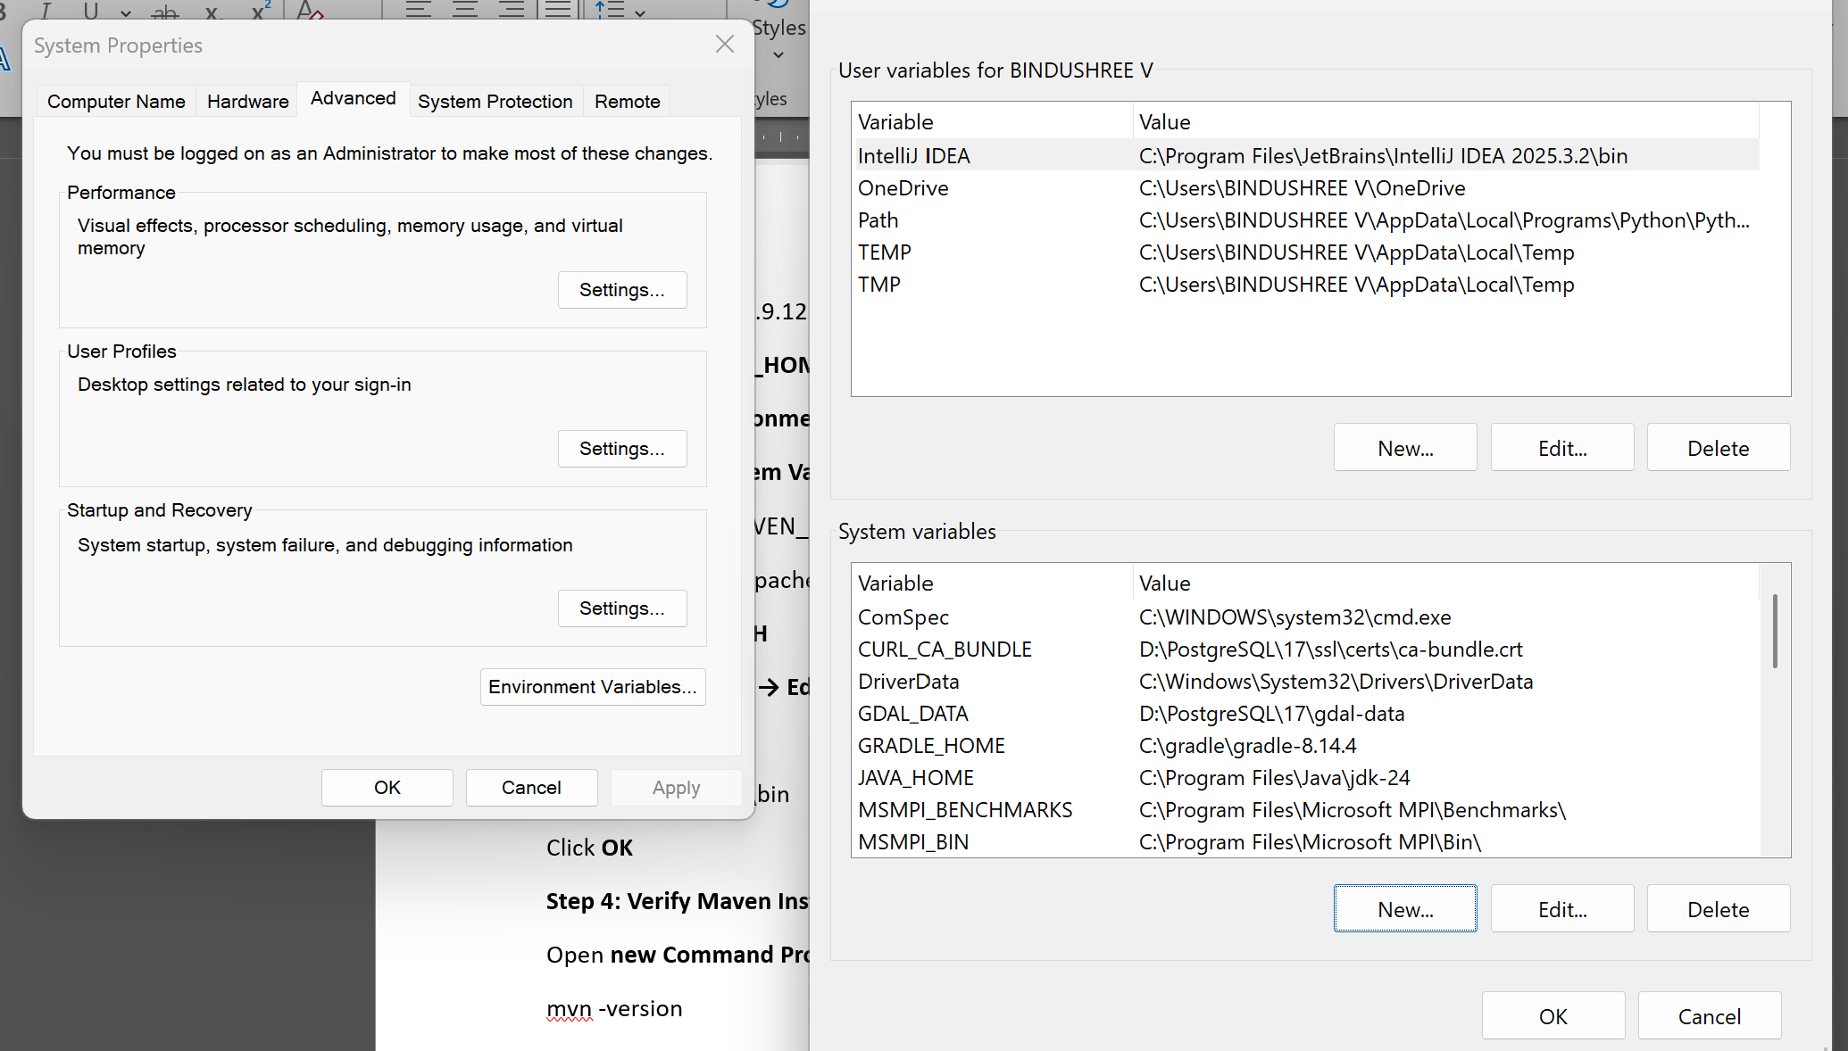

- Under System Variables → New
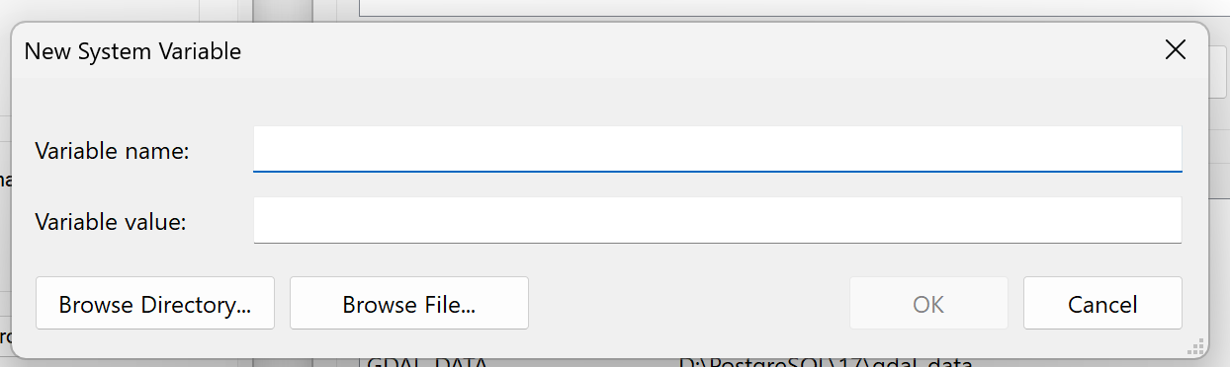
Variable Name: MAVEN_HOME
Variable Value: C:\apache-maven-3.9.12 (this is the location of the maven-3.9.12)
Step 3: Update PATH
- Select Path → Edit
- Add:
%MAVEN_HOME%\bin
Click OK
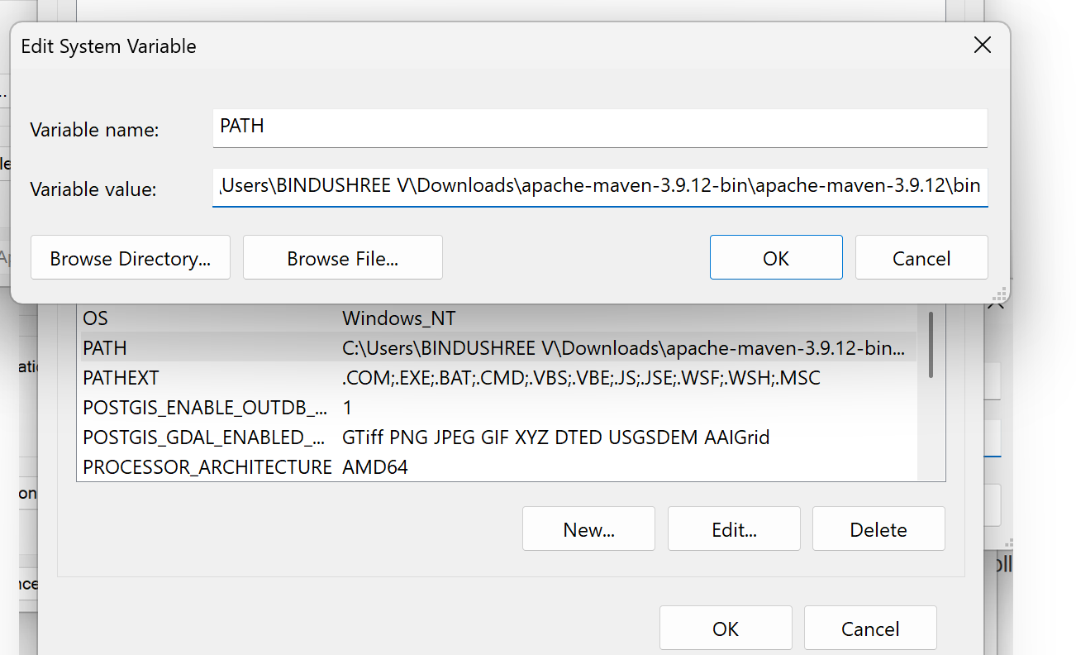
Step 4: Verify Maven Installation
Open new Command Prompt:
mvn -version
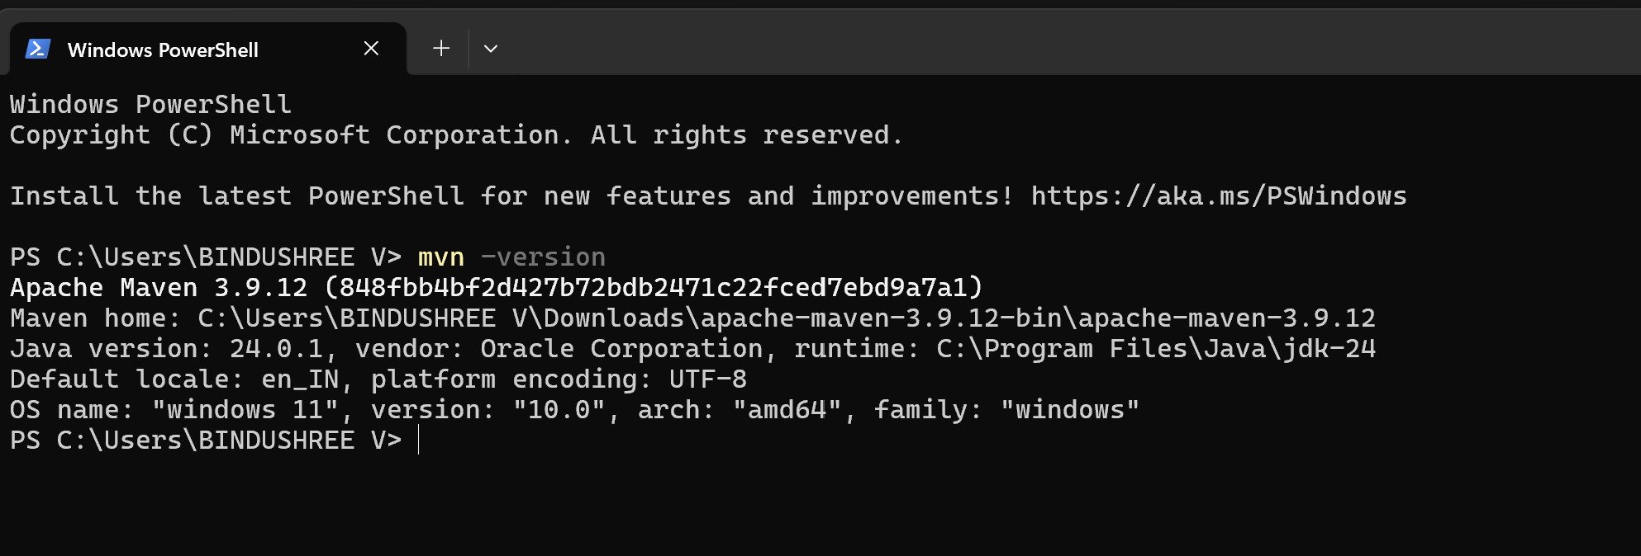
Maven version displayed
Java version displayed
Maven installed successfully

Installing Gradle
Step 1: go to chromeàDownload Gradle
- Download Gradle binary zip
- Extract it
Example location:
C:\gradle-8.x
Step 2: Set GRADLE_HOME
- Open Environment Variables
- Under System Variables → New
Variable Name: GRADLE_HOME
Variable Value: C:\gradle-8.x (this is the location of the gradle)
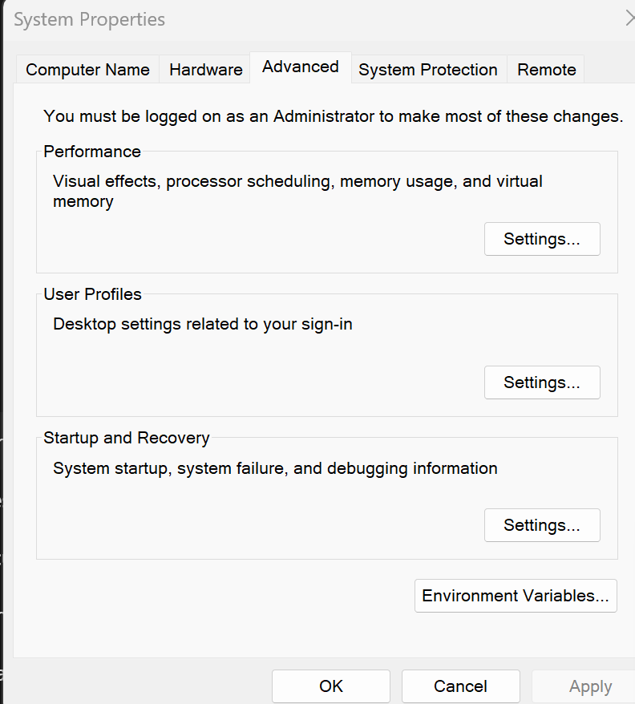
Step 3: Update PATH
- Select Path → Edit
- Add:
%GRADLE_HOME%\bin
Click OK

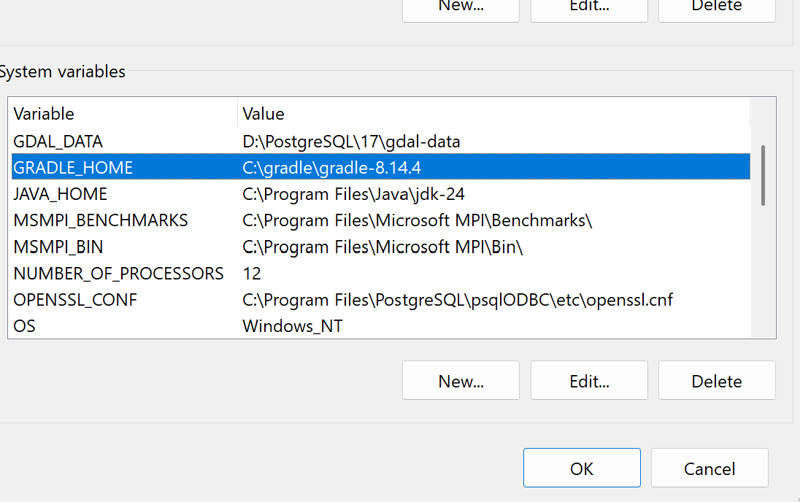

Step 4: Verify Gradle Installation
Open new Command Prompt:
gradle -version
Gradle version displayed
Java version displayed
Gradle installed successfully
